Part 1: Hello you!
- screenshot of script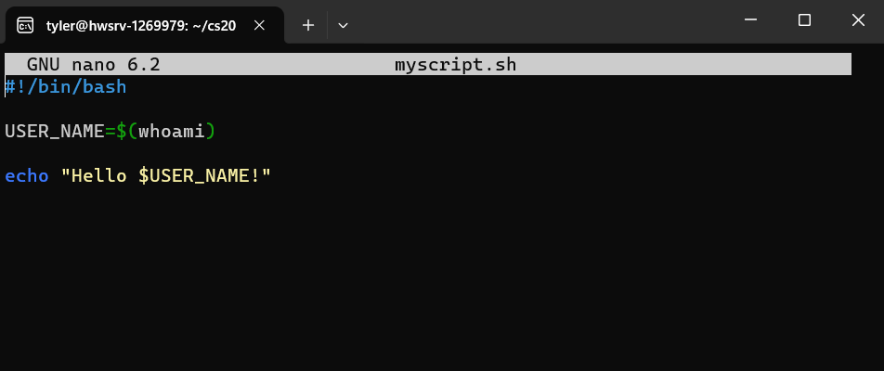
- screenshot of the output produced by the script
- Explanation:
  - #!/bin/bash: is the shebang that indicates the script should be run using the Bash shell.
  - Whoami: retrieves the current user's name.
  - USER_NAME=$(whoami): stores the output of the whoami command in the USER_NAME variable.
  - echo "Hello $USER_NAME!": prints the message, replacing $USER_NAME with the actual username.

Part 2: Special Shell Script Parameters
- screenshot of script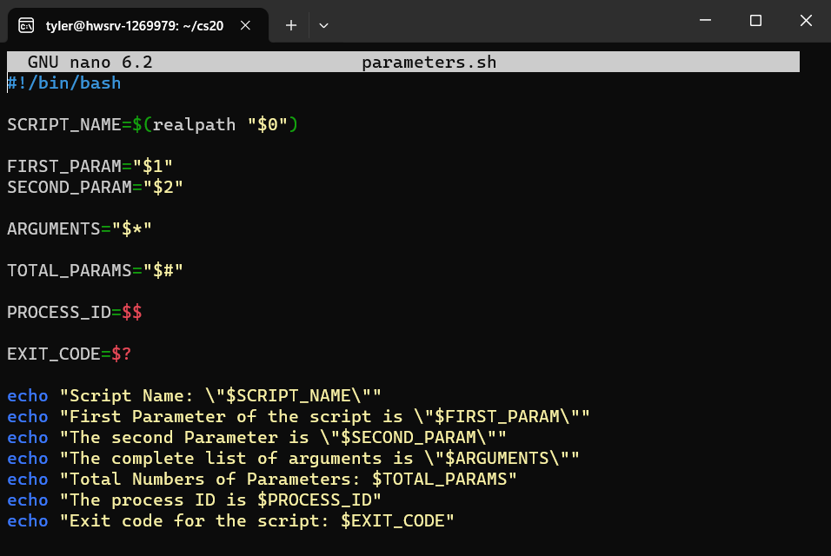
- screenshot of the output produced by the script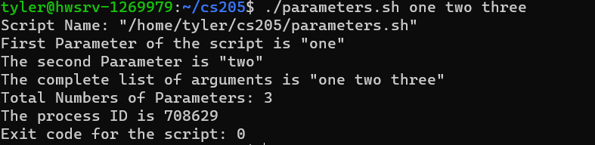
- Explanation:
  - SCRIPT_NAME=$(realpath "$0"): realpath is used to get the absolute path of the script.
  - FIRST_PARAM="$1" and SECOND_PARAM="$2": These store the first and second parameters passed to the script.
  - ARGUMENTS="$*": This stores all the arguments as a single string (separated by spaces).
  - TOTAL_PARAMS="$#": This retrieves the total number of arguments passed to the script (not including the script name).
  - PROCESS_ID=$$: This gets the process ID of the running script.
  - EXIT_CODE=$?: This stores the exit code, which should be 0 unless there’s an error in the script.

Part 3: Hello you - Advanced
- screenshot of script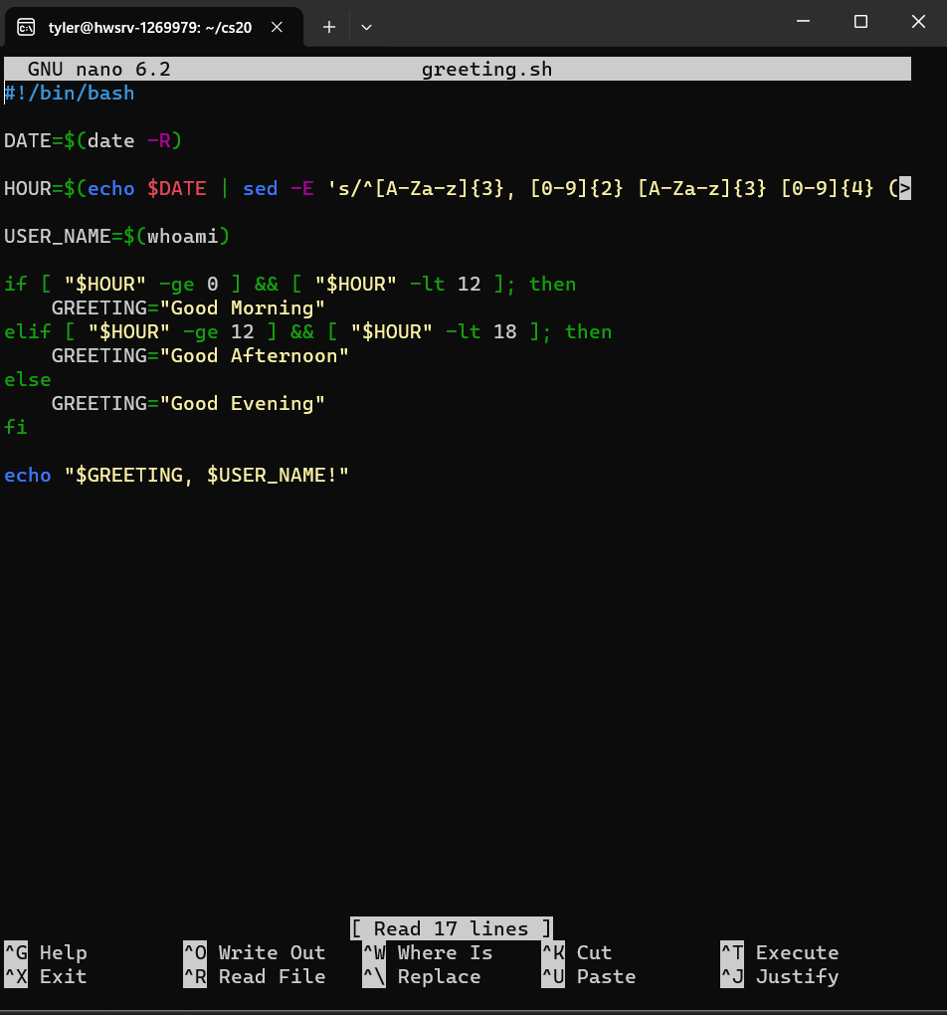
- screenshot of the output produced by the script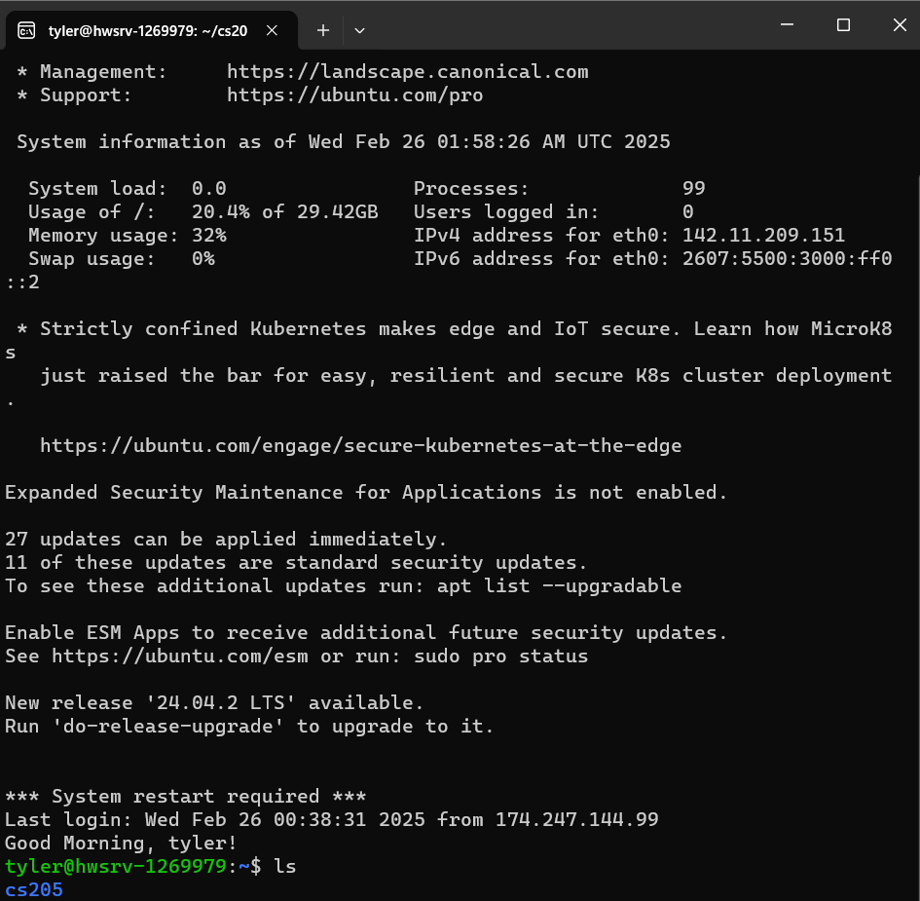
- Explanation:
  - Get Date with date -R: The date -R command produces a string like Mon, 25 Feb 2025 14:20:30.
  - Extract Hour Using sed: The sed command is used to extract the hour part (the first two digits in the time, such as 14 for 2 PM).
  - User Name: whoami is used to get the current logged-in user's name.
  - Determine the Greeting:
    - If the hour is between 0 and 11, the script outputs "Good Morning".
    - If the hour is between 12 and 17, it outputs "Good Afternoon".
    - Otherwise, it outputs "Good Evening".
  - Output the Greeting: Finally, the script outputs the appropriate greeting with the user's name.
Part 4: Automatically renaming Files
- screenshot of script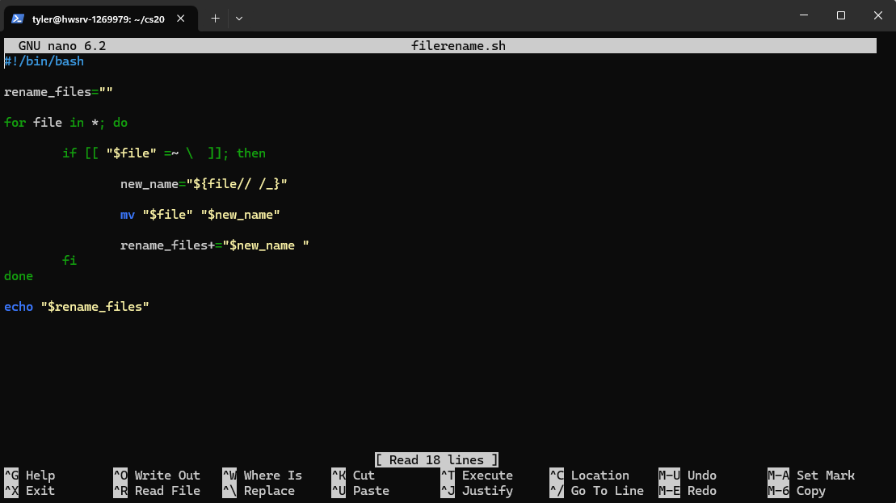
- screenshot of the output produced by the script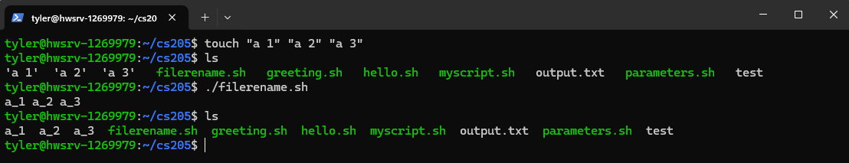
- Explanation:
  - File Looping: The for file in *; do loop iterates through all files in the current directory.
  - Space Check: The condition [[ "$file" =~ \ ]] checks if the filename contains spaces using a regular expression.
  - Renaming: The expression ${file// /_} replaces all spaces in the filename with underscores.
  - Renaming Execution: The mv command renames the file.
  - File Collection: The script appends the new filenames to the rename_files variable, followed by a space.
  - Output: Finally, the script outputs the renamed filenames on a single line using echo.

